Virgin Mobile KSA App - Customer Onboarding
This document outlines the onboarding steps for new customers using the Virgin Mobile KSA mobile application. It covers the customer journey starting from selecting a number, choosing a plan, and verifying eligibility, before reaching the account login page. Each step includes visual references to provide a clear understanding of the app interface.

Step 1: Choose Your Number
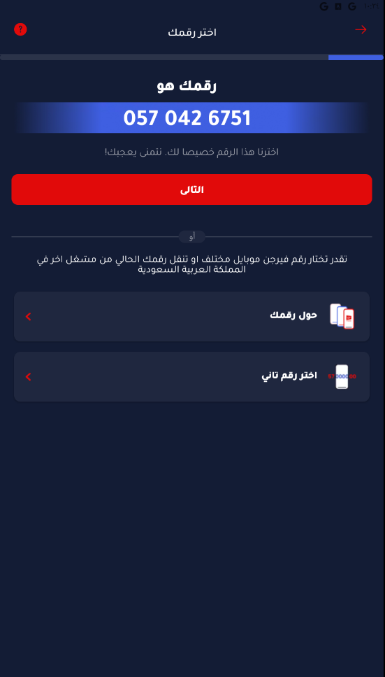
The onboarding process begins with choosing a mobile number. The app assigns a suggested Virgin Mobile number (e.g., 057 042 6751), which the user can accept or choose to replace. Users can also opt to port an existing number from another service provider within Saudi Arabia.

Step 2: Select Your Plan
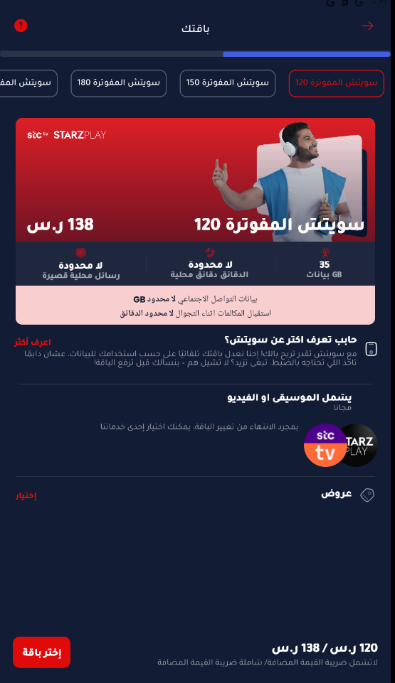
Once the mobile number is chosen, the user proceeds to select a suitable plan. Virgin Mobile offers multiple postpaid plans such as:
- **Switch 120**: 35 GB, unlimited local minutes, and access to STARZPLAY.
- **Switch 150 / 180**: Higher-tier plans with additional GB and benefits.
These plans are displayed with pricing and key features like local SMS, social media data, and free streaming access.

Step 3: Verify Eligibility
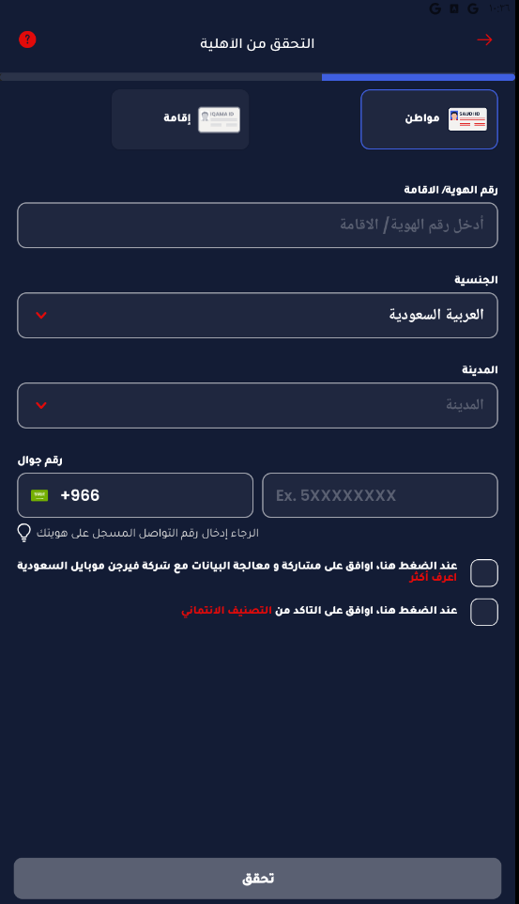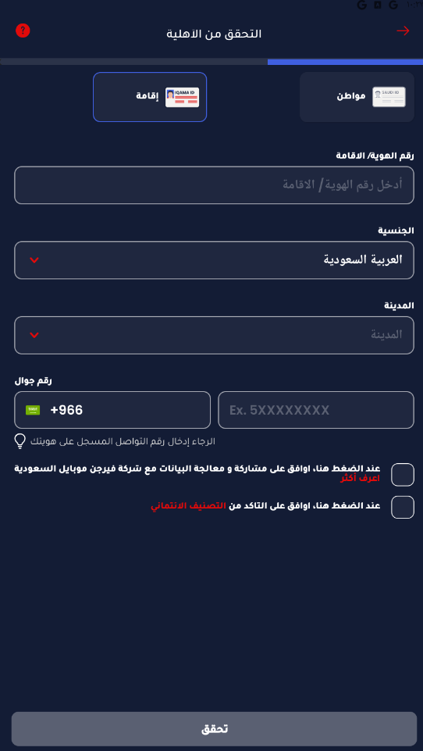

After selecting a plan, the user is required to verify their eligibility. This step differs for Saudi citizens and residents (Iqama holders). Required fields include:
- **National ID or Iqama Number**
- **Nationality and City**
- **Mobile Number registered with Absher**
Users must check two consent boxes to proceed:
- Approval for sharing and processing personal data.
- Approval to confirm credit rating eligibility.

Optional: Explore Available Plans Before Registration
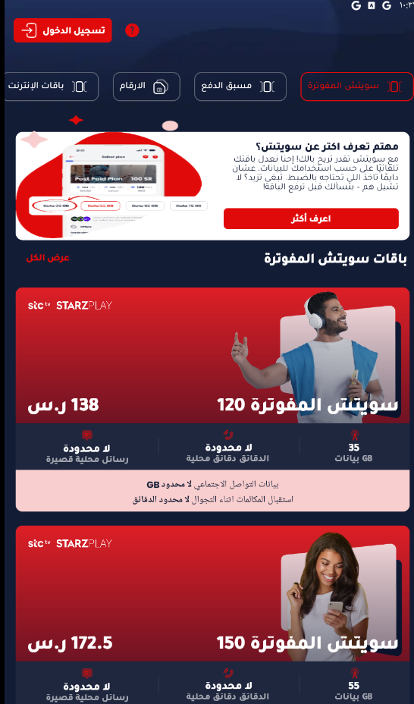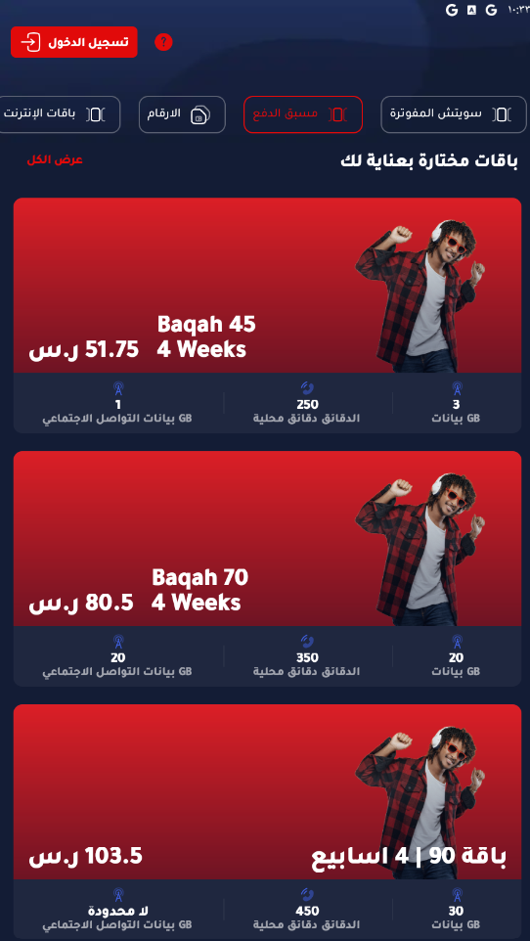

Even before starting the registration, users can explore the app’s offerings. This includes browsing various prepaid and postpaid bundles, selecting numbers, and comparing services.
- **Postpaid**: Switch packages with streaming services.
- **Prepaid**: Short-term bundles like Baqah 45, 70, and 90.
- **Number Selection**: Browse standard and premium numbers, with prices if applicable.

Final Step: Login or Register an Account
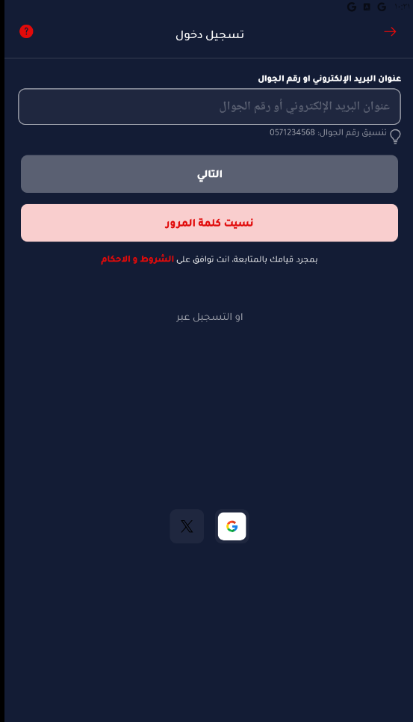
After completing the onboarding process, users are directed to the login page. They can sign in using their email or mobile number. There are also options to login via Google or Apple ID. If users forget their password, the app provides a password recovery option. Accepting the terms and conditions is required to continue.

